drop table tblFruit
drop table tblFruitDetail;

create table tblFruit
(
FruitNum INT,
Fruit Varchar(15)
);
CREATE TABLE tblFruitDetail
(
VendorName VARCHAR(25),
FruitNum INT
);

insert into tblFruit values(1, 'Apples');
insert into tblFruit values(2, 'Oranges');
insert into tblFruit values(4, 'Bananas');
insert into tblFruitDetail Values('Johnny Appleseed',1);
insert into tblFruitDetail Values('Bobs produce',1);
insert into tblFruitDetail Values('Orangatang Oranges',2);
insert into tblFruitDetail Values('Bobs Produce',2);
insert into tblFruitDetail Values('Marys Grapes',3);

tblFruit | tblFruitDetail
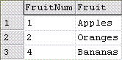 | 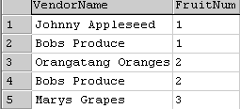
(Left tables are highlighted (see tblFruit))
Equal Join
SELECT tblFruit.FruitNum, tblFruit.Fruit, tblFruitDetail.VendorName
FROM tblFruit, tblFruitDetail
WHERE tblFruit.FruitNum = tblFruitDetail.FruitNum;
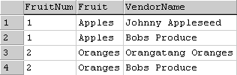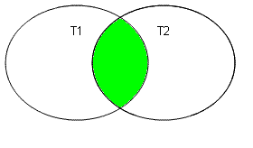

Left Join
SELECT tblFruit.FruitNum, tblFruit.Fruit, tblFruitDetail.VendorName
FROM tblFruit
LEFT JOIN tblFruitDetail ON tblFruit.FruitNum = tblFruitDetail.FruitNum;
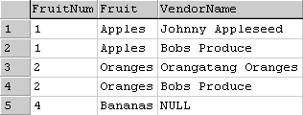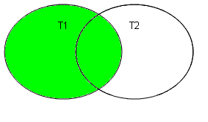

RightJoin
SELECT tblFruit.FruitNum, tblFruit.Fruit, tblFruitDetail.VendorName
FROM tblFruit
RIGHT JOIN tblFruitDetail ON tblFruit.FruitNum = tblFruitDetail.FruitNum;
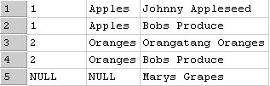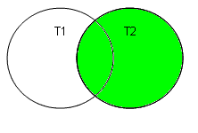

Full Join
SELECT tblFruit.FruitNum, tblFruit.Fruit, tblFruitDetail.VendorName
FROM tblFruit
FULL JOIN tblFruitDetail ON tblFruit.FruitNum = tblFruitDetail.FruitNum;
